**Quality Hospital Care**

**for People with Intellectual Disabilities**

**Learning Resource**

**Activity Booklet Group**

**Family/Close Others Pathway**

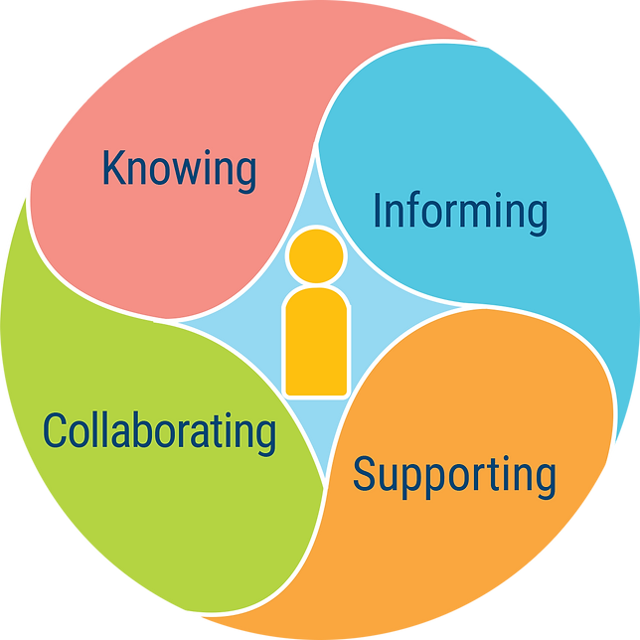

https://www.hospitalinclusion.au



Family / Close others: Emergency Department

If you have the opportunity to discuss these resources with other families or close others, we encourage you to share responses to each of the following:

1. Describe previous hospital experiences that cause you to anticipate problems.

Click or tap here to enter text.

1. Discuss how each of the following could avoid these problems in future hospital encounters

* Sharing information about what can result in distress for your family member.

Click or tap here to enter text.

* Sharing information about what could alleviate this distress.

Click or tap here to enter text.

* Ensuring that any involved disability support workers and hospital staff can readily contact you.

Click or tap here to enter text.

* Who should be involved in the collaboration.

Click or tap here to enter text.

* What hospital staff could do to demonstrate their willingness to collaborate in delivering quality care to your family member.

Click or tap here to enter text.

* What you could do to demonstrate your trust in hospital staff and willingness to collaborate in providing care and support to your family member.

Click or tap here to enter text.



Family / Close others: Transitions

If you have the opportunity to discuss the content of this website with other families or close others, we encourage you to share responses to each of the following:

1. Compare Jeff's experience in this scene with your own experiences with a family member/ close other with intellectual disability.

Click or tap here to enter text.

1. Describe any transitions, in general, that your family member has difficulty with.

Click or tap here to enter text.

1. Explain how these difficulties might play out if they are in hospital.

Click or tap here to enter text.

1. Describe strategies that could support them during these transitions.

Click or tap here to enter text.

1. Identify information you would share with hospital staff to help them adopt these strategies.

Click or tap here to enter text.



Family / Close others: Ward Stays

If you have the opportunity to discuss the content of this website with other families or close others, we encourage you to share responses to each of the following:

1. Describe any concerns you have when your family member or close other has stayed or could require a stay in a hospital ward.

Click or tap here to enter text.

1. Explain what would allay these concerns.

Click or tap here to enter text.

1. Identify specific strategies that you would like the hospital to use to address your family member/ close other's health or personal care needs.

Click or tap here to enter text.

1. Now identify variations to those strategies in situations in which hospital staff are not able to implement your original strategy.

Click or tap here to enter text.



Family / Close others: Discharge

If you have the opportunity to discuss the content of this website with other families or close others, we encourage you to share responses to each of the following:

1. Describe your experiences of discharge planning for a family member or close other with intellectual disability.

Click or tap here to enter text.

1. Compare the collaboration demonstrated in the discharge meetings you observed for Jeff and Cassandra to your own experiences.

Click or tap here to enter text.

1. List key information that you would like to see shared - record the contributions from each person in the group.

Click or tap here to enter text.

1. Explain and compare how you would each feel if the final decision or outcome differed to your own preference but did align with the preference of your family member/ close other.

Click or tap here to enter text.